Changes to Make.

Page 1 Main Page.

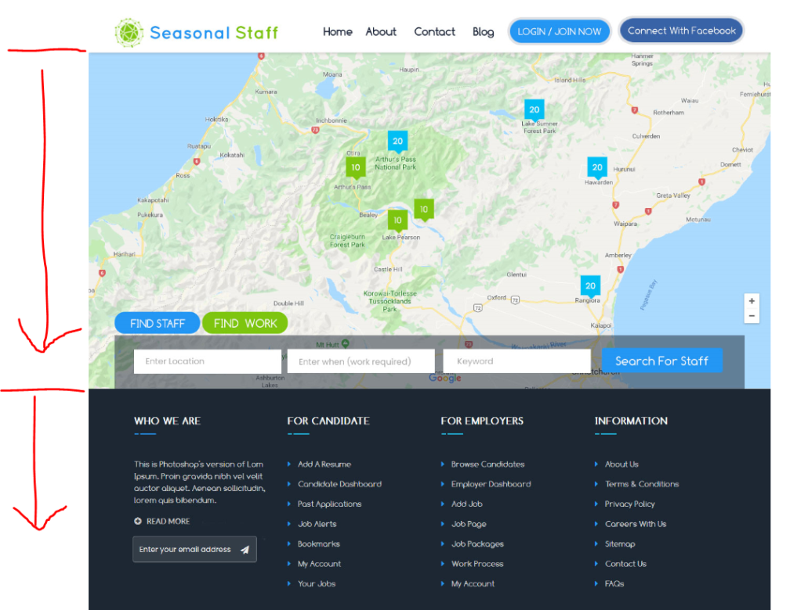

**Changes to be made.**

1. Please can the map of New Zealand take up more of the screen (be larger) and set that it shows more of New Zealand, as the part of New Zealand it is set on is actually quite a remote part of New Zealand. I have provided an example of the default
2. Move the dark area down so it has to be scrolled to see it. I want the map and search buttons to be the feature of the front page.

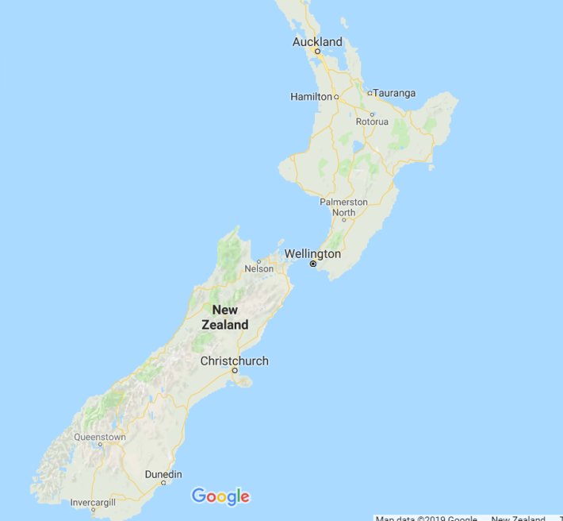

**Page 2 Sign up changes**

Please refer to the last changes I suggested (as these two changes where not completed)

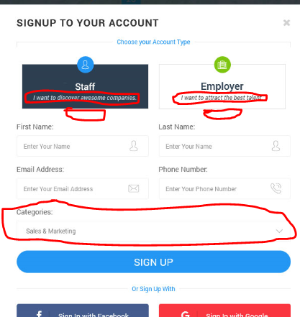

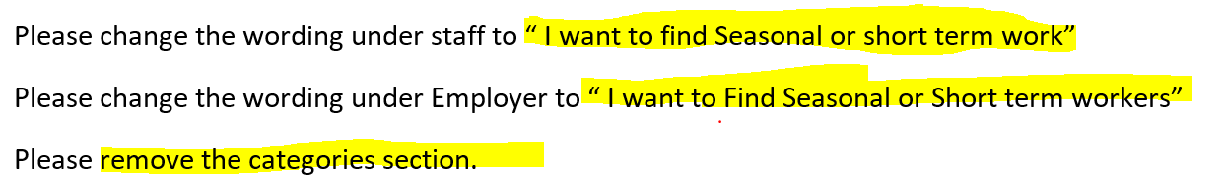

Can you please also put a link on the page under each one to link to the pricing page.

******Very Important ******Please can there be a section on the “sign up page” where users can put in a code. This code would give them access to special pricing and would allow us to be able to track where the business has come from. Eg if we run a promotion we can track its effectiveness by how many people signed up using this code. The Admin needs to be able to amend, add and remove codes in the backend. This needs to be on both Staff and employer sign up

**Page 3 Sign in changes**

Please make the working changes as above

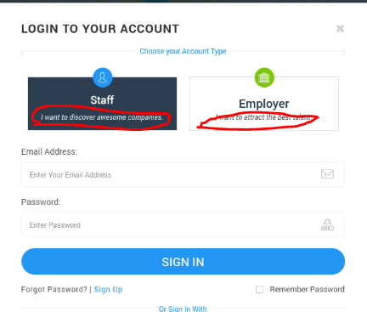

**Page 4 Find work page changes.**

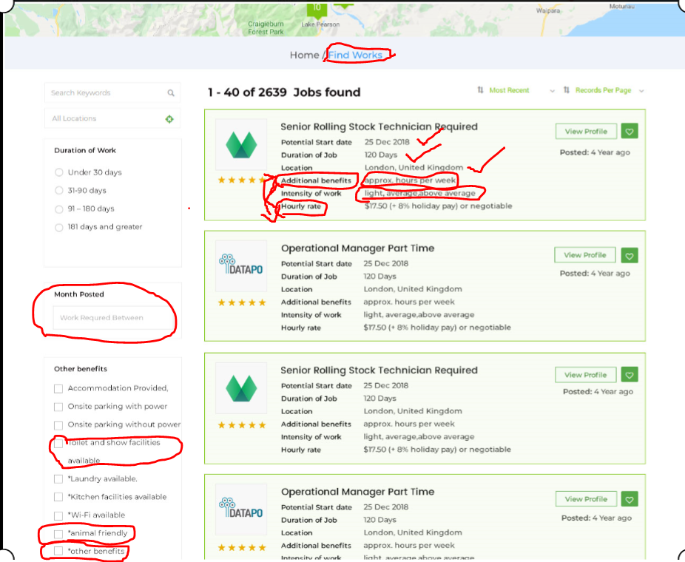

1. Change “Find works” To Find Work” remove the “s”
2. On the jobs found profiles, Please put “hourly rate” below the “Location” heading.
3. Then put “Approx hours per week” below “hourly rate” Please change “ Approx hours per week “ to “Hours per week” (this should be a heading)
4. “Intensity of work” Below “Hours per week”
5. “Additional Benefits” below “Intensity of work”
6. Please can you remove “month posted” but change this so they can search a “date period”
7. Please change “Toilet and shower facilities available” to “Toilet & Shower facilities”
8. Please add “ Can help Find Accommodation / Parking …please add below “Onsite parking without power”
9. Please change “animal friendly “ to “Animal Friendly Workplace”
10. Please change “other benefits” to “Other Benefits”

**Page 5 works detail page changes**

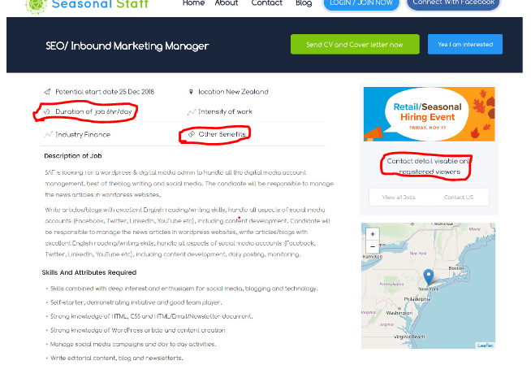

1. “Duration of Job” should be the same number as on the find works page so should be the length of the job which will be in days.
2. Please add “hours per day” as a heading. Please put “hours per day” where “work intensity” is
3. Move “intensity of work” to where “Other Benefits” are.
4. Move “Other Benefits” underneath “Industry”…. In the “Other Benefits” area… this should list… e.g. Powered parking, Toilet & Shower Facilities, Wi-Fi,
5. Please change “Contact details visible only registered viewers” please change to “Contact details available to registered users”
6. Please can you add the rating of this business “e.g. number of stars” needs to show on this page.

Page 6 Employer dashboard changes.

Sharon come back and look at order of left hand items in dashboard

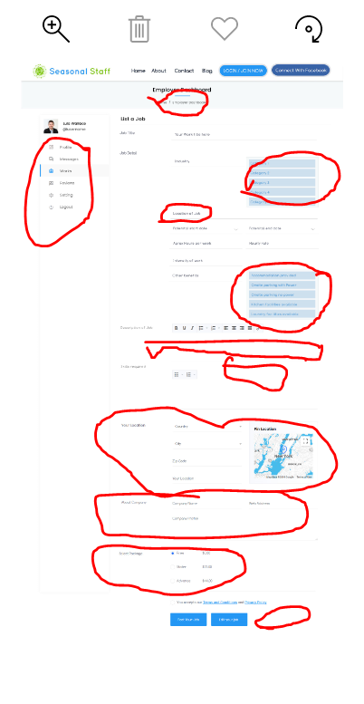

1. “Please can you rename these headings on the left hand side?” Change “Profile” to “Business Profile”, Can you change “works” to “Manage Employment” change “Setting” to Settings”
2. Under “Manage Employment” There should be a drop down menu and “list a Job” Should replace “list a works”(see Employer manage candid on next page)
3. Under the large heading of Employer Dashboard, there is a small heading that says “Home / Employer Dashboard. Please can you change that to the following The order of the left hand list” When listing a job this should show under “Home / Manage Employment”
4. I am wanting the industry part to be a drop down menu like this, Just wasn’t sure if what was there was doing that. Please can you ensure that it does.

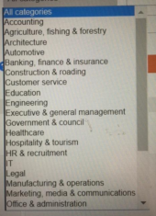

1. “Location of Job” This should pull from business profile and should be shown as a city, or suburb they should not be able to put free text in this box.
2. Please also check that “intensity of work” is a drop down menu of three choices , light work, average, above average (please check this)
3. “Other benefits, can you please ensure that this is a check box section where employers can check as many of them that apply not just one. Please see picture example I have given you

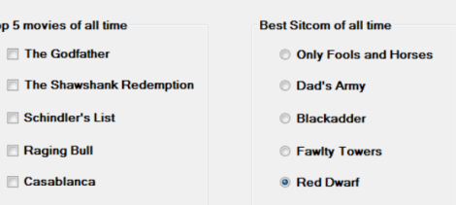

1. Where “Description of job” is please can you have a prompt to say (enter description of job here). Can you also indicate the box that they are to type in by making it a light blue colour? (it needs to be obvious where they need to type)
2. Change “Skills required” to Skills & Attributes required” please can you also have a prompt to say (list Skills & Attributes here), Can you also indicate the box where they need to start by making it a blue shaded area. (can you put a limit of the number they can add)
3. “Your location” This is almost a double up. There should be no need for the employer to have to fill these details out they should pull through from their profile details.
4. “Package settings” could there be three options. 1. Indicate Urgency” … $ 2. Notify nearby workers” $ 3. “notify workers with specific skills” $
5. “Indicate urgency” would make the flag of the job pulsate. But his would only last for 7 days.
6. “notify nearby workers” This would send an email and text notification to nearby workers that there is a job close by that needs a worker”
7. “notify worker with specific skills” This allow the employer to put in key words or phrases which the database would search and would send them an email and text notification that there is a job’ that requires skills they have”
8. At the bottom of the page where it says “post job” and “edit job” can you please also add “save as draft “ button
9. Can you change “profile” to “Business profile” “works” to “Manage Employment” change “Setting” to “Settings”

Page 7 Employer Manage candidate page changes.

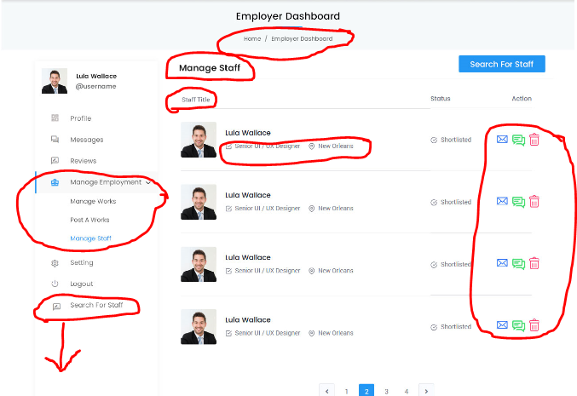

1. The following has been previously asked for can I check that they have been actioned. (Have some way to indicated that a chat has happened with that person. Eg bubble is darker colour, also to indicate When was the last contact, Please can you put a date here,
2. Have three status, Applied, Shortlisted and Unsuccessful. Could this now be four status to included “Employment accepted”
3. Applied – would indicated that the a staff has indicated interest. But no response or contact has yet been made. (is it possible that the Seasonal Staffer gets notifcation when the application has been read)
4. Shortlisted – This would be where the employer has indicated interest in the staff, (if it is possible that the seasonal staffer gets notification when they have been shortlisted)
5. Employment Accepted- This would mean that an employment offer was made to the employee. This could have been made outside the site. The Employer would need to manually change this status, and this would create and automatic email “sent from Seasonal Staff” saying (Congradulations on accepting a new Job with XXXXX” – Don’t forget to fill in a Review of your Employer” By and Employer changing the status it would then allow them to be able to put a reivew on the staff member. A staff member could not put a reivew on the Employer unless this status was changed.
6. Unsuccessful – This would be where the employer is not interested in taking their interest any further. (This would generate an automatic email advising the staffer they were unsuccesful) The Employer would then be able to delete.
7. This has already been asked for can you please check that it has been done, as it is difficult to see from the screenshot….Is it also possible to show if an email or chat has been read.
8. This has alredy been asked for on each of their profiles.. can their current location and when they were last be displayed here please
9. Change the page heading from “Manage Staff” to “Manage Applicants” also change this on the left hand panel.
10. Change “Staff title” to “Applicants”
11. Can the “Search for staff” on the left hand side be the same button as up on the right hand side but… can it be lower down below the “log out button”
12. Not sure if it will be done, but when you hover over the three icons (the email, the Chat and the Trash) can they say the following. Email (Send a email), Chat (start a chat) and Trash (Send a decline & Delete)

**Page 8 Employer Manager Job page changes**

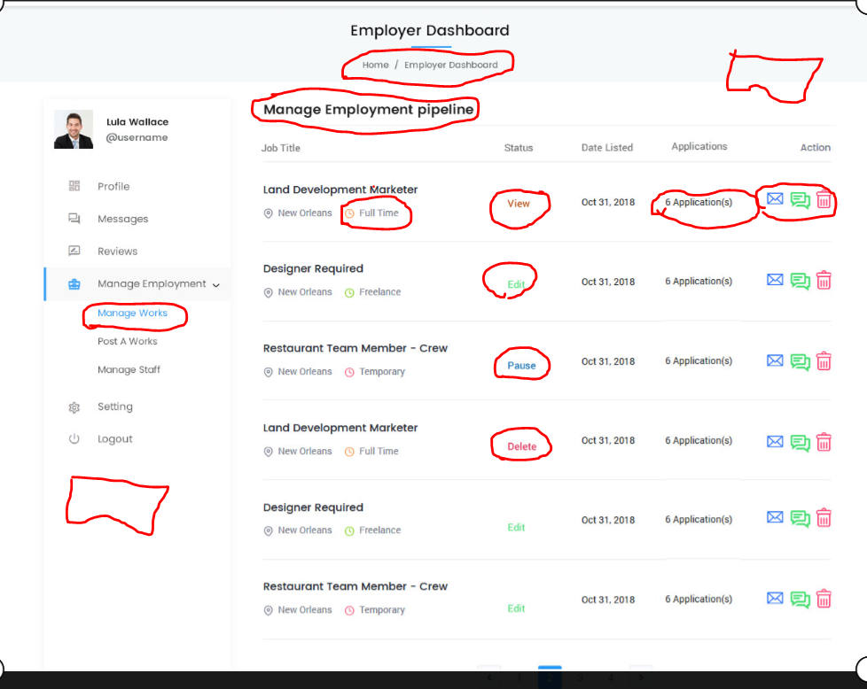

1. Please ensure that at the top of each page when in the dashboard that they indicate what area they are in eg… “Home / Employer dashboard” should be “Home / Manage Employment.”
2. Can you change “Manage employment Pipeline” to “Manage Jobs”
3. Can you Change “Manage works” to Manage Jobs”
4. Can you please ensure that the “Search for staff” big blue button is on the top right of the page and bottom left under the “log out”
5. Please remove the icon and the words “ Temporary, freelance or Full time” we wont need this.
6. Please change “pause” status to “Advert On hold”
7. In the Status Please remove “View” If they wanted to view the add they should just be able to click on the “job title “ and it should take them to the job advert. (here they can press “edit or “Put advert on hold”
8. Under status there should only be 3 status, “Advert On hold” , “Active” and “Draft”
9. If a status is “Advert On hold” this advert does not apprear on the map and is not available for seasonal staff to see or apply to.
10. If a status is “Active” the advert is available for all seasonal staff to see and apply to.
11. If a status is “Draft” the advert is not published and is still a work in progress. No staff can see this advert until it is completed.
12. Remove “Delete” from the Status section this should show as an icon on the right hand side.
13. Remove “Edit” from the Status section, this should show as an icon on the right hand side. – by hitting the “Edit”button it will take them to where they can “Edit “ the Advert
14. “Applications” can the “applications” be a button or a link that takes the Employer straight to the list of applicants that have applied for that job.
15. “Email, Chat and Trash Icon” (please change as indicated below)
16. Please can the Email Icon enable the employer to send a bulk message to all the applicants for that Job. – this would be a message the Employer could type out and send to all applicants” When you hover over the email icon it woud say “Send a bulk email to applicants”
17. Please can you remove the “chat” Icon here and replace with an “Edit icon” This would take the employer straight to the page where they could edit their ad. When you hover over the edit icon it would show “Edit advert”
18. Keep the “Delete” Icon. This icon would be used if the employer wanted to delete an advert. If they hover over the delete icon it would show “ Delete Advert” If they pressed “Delete” prior to deleting the advert, a message would come up to Say “are you sure you want to delete this advert, with a “Yes or No” button” If they pressed “Yes” a box would come up that would prompt the employer to “change the status of any applicants to “offer made” so they could add a review later and would also prompt the employer to send a “bulk email” advising all applicants that the position is not longer available.

**Page 9 Employer Message page Changes**

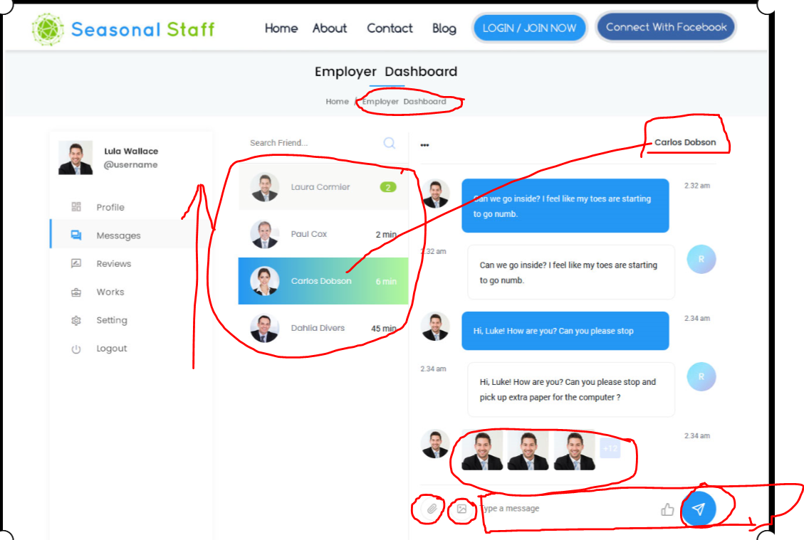

1. Please change” Home / employer Dashboard” to Home / Messages
2. Please increase the size of the name of the person that is being chatted to (on the right hand side) perhaps use their photo up there.
3. Just confirming the the paper clip Icon allows both employer and staff to attach something like a pdf etc.
4. Just confirming that the Photo Icon allows both the employer and staff to attach photos.
5. Just checking that the most recent “chat” notification (middle coloum) be listed at the top.
6. Please can you make the “chat box” quote obvious eg… shade it so it is obvious.
7. Just checking that the most recent chat will display above the chat box.
8. An icon on the right hand side show if the last message has been read.

Page 10 Employer reivew page changes.

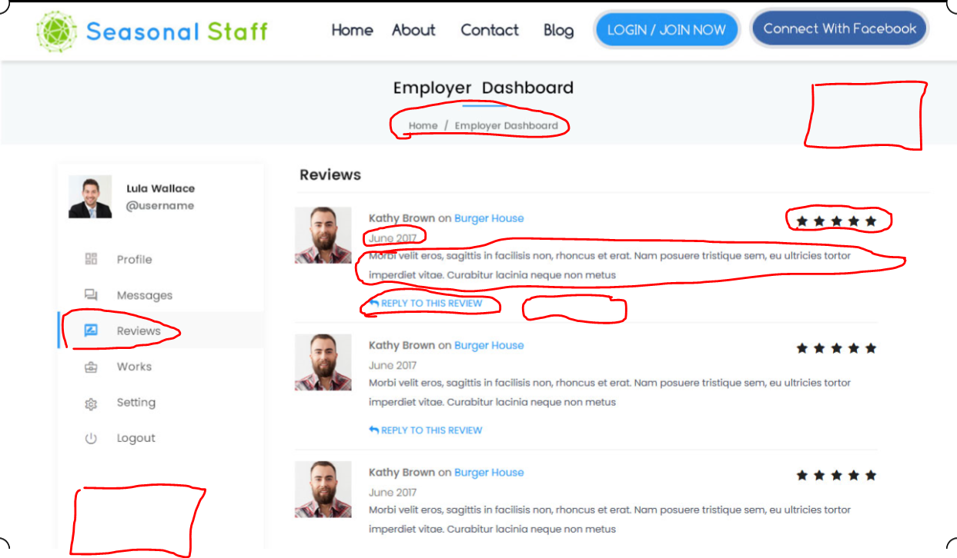

1. Please change “Home / Employer Dashboard” to “Home / Reviews
2. Under the “Reviews” tab there needs to be a drop down, which will be“ Our Reivews” and “post a review” “ Our Review” is the page I am doing Now.
3. Please change “ Reivews” to “Our Reviews”
4. On the date of the review can the reivew have a full date. Eg 11 March 2018
5. The Review comments are only viewable by the business but and average overall rating would be able to be seen on the business and for the staff member. ( I have explanations which I will attache what is considered to be a 1,2.3.4 & 5 star
6. Can the “reply to this reivew” be a button that sends a comment via email back to the staff member who put ont the reivew. (this is not to be public information)
7. Can beside the “ reply to this reivew” be a button which takes the employer to being able to reivew the staff member, if they have not already done so.
8. Please put the big blue “Search for Staff” button on the top right and the bottom left of the page.
9. Beside the 5 star review would be a link that would explain the what a four rating would be. And would also have the number of reveiws completed and the average of those reivews would be what is their rating.
10. As side benefit to the rating system is that the Higher the reivews eg 4 or a 5 the higher the employer or staff member would appear up the list. (they would not need to pay to promote or feature their listing)
11. “post a review” would take them “employer Manage candidate page” I expect that to post a reivew on a staff member their status would need to show as “Employment accepted” . Once the Employer updated the status to “Employment accepted” it would automaticly generate an email to be sent to both parties congradulating them” This would then unlock the review button on each party.

Page 11 – Jobs posting – I believe this is a double up of Employer Dashboard “list a Job”

Page 12 – find staff page changes

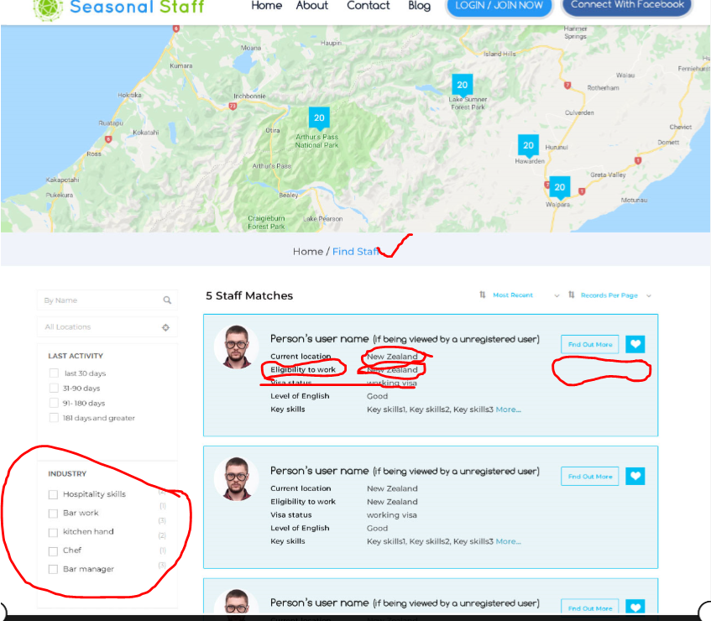

1. Current location. Please can this show a location eg city or a suburb not a country.
2. Please can you change “Eligible to work” To “Eligible to work in NZ” This would be a yes, no or Unsure drop down list. Please make this a complusary field. That has to be filled in.
3. Please remove the reference to” Visa status.”
4. Below “Find out more” please can the review stars be shown,
5. Below the “Review stars” please can you put when this user was last online.
6. I have provided you a list of industries below to use for the industry section please use this on all sections that refer to industries.

List of Industries.

All categories

Accounting, finance & legal

Agriculture, fishing and forestry

Construction & roading

Film, television & Entertainment

Government and council

Health care & Education

Horticulture & Viticulture

Hospitality and tourism

IT & Technology

Manufacturing & operations

Marketing & communications

Office, Admin & HR

Property

Retail Sales & Customer Service

Trades and services

Transport & automotive

Other

Page 13 – Staff details page changes.

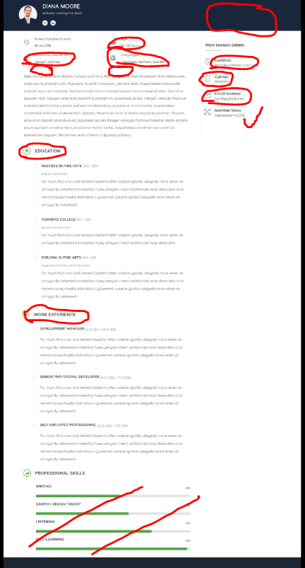

1. Here is a list of all the regions that the staff member will be able to select, “ or any location” there are 16 of them all together.

Northland, Auckland, Waikato

Bay of Plenty, Gisborne, Hawkes Bay

Taranaki, Manawatu-Whanganui

Wellington, Tasman, Nelson,

Marlborough, Westcoast,

Canterbury, Otago, Southland

1. Please add in below “locations considered” “ Level of fitness” this would be a dropdown list, of only three options “below average, Average, above average”
2. Please add in below “ Languages” “Level of English” this would be a drop down list, of only three options “Below average, average and above average”
3. Where “location” is displayed on the right hand side can this be changed to “Current location”
4. Where “Cell No” is displayed please can you change this to “contact phone number” This would be an option that the staff could display if they wanted but was not compulsory”
5. Where “Email Address” is shown please remove this and instead put up an button Up the top please can the button be made so that an employer could make contact with the staff member to see if they are interested in a job can you name this button “ Send them an email” please make this button green.
6. Where the “Email Address” is shown, replace this with “start a chat” icon.
7. Please change “Education “to “Key skills and Attributes”, and allow the staff to add text here to a maximum of 50 spaces. They can add up to 15 bullet points
8. Please change “Work Experience” to “Relevant Qualifications” and allow the staff to add text to 100 spaces. (They could add up to 15 bullet points.)
9. Remove the” professional skills” section.

Page 14 user profile – page changes

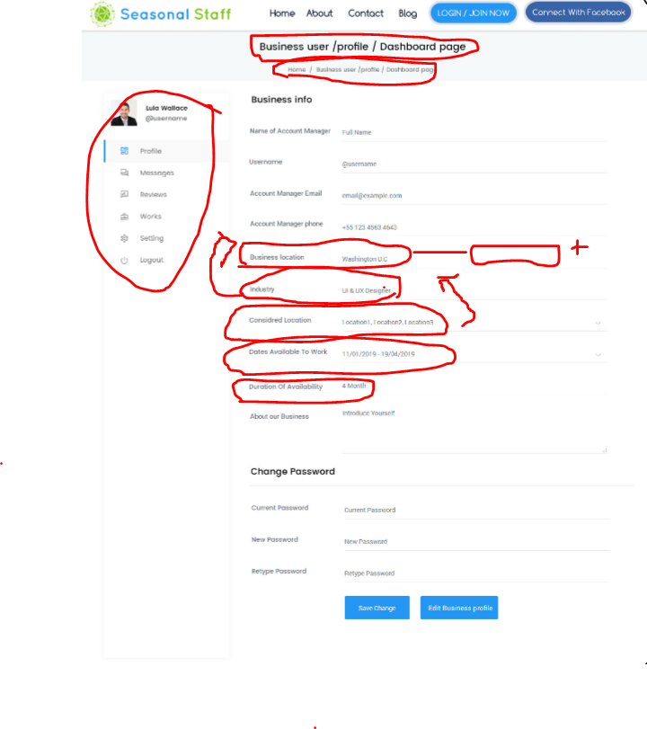

1. Up the top of the page where it says “business user / Profile / Dashboard page” Please can you change this to “Dashboard Page”
2. Underneath this can you please change “Home / business user / profile / dashboard” to Home / Profile
3. Can the Menu down the left hand side of the page be consistent with what is in the other dashboards e.g.” works “should be “Manage Employment” “setting” should be “Settings”
4. Please can you move “Industry” to under account manager phone number
5. Can you please add these industries in Under “Industry” so they can be selected from a drop down menu

Accounting, finance & legal

Agriculture, fishing and forestry

Construction & roading

Film, television & Entertainment

Government and council

Health care & Education

Horticulture & Viticulture

Hospitality and tourism

IT & Technology

Manufacturing & operations

Marketing & communications

Office, Admin & HR

Property

Retail Sales & Customer Service

Trades and services

Transport & automotive

Other

1. Where “Business location” is please change to “Main business location”
2. Beside “Business location” can there be a button that says “Add another business location” (When this button is pushed) it allows the business to add another business location that can then be selected when they are creating a “job advert” (This is important )because there are business that have multiple locations Each additional location would incur a charge to use the site ..E.g. $499 + GST for the first Business then $199+GST for every additional business location.
3. Can you change “ Considered locations” to “Additional business locations” and put this directly under “Main business location”
4. Please remove “Dates available to work” and “Duration of work” as these will be detailed in each of the adverts.

Page 15 user applied jobs changes.

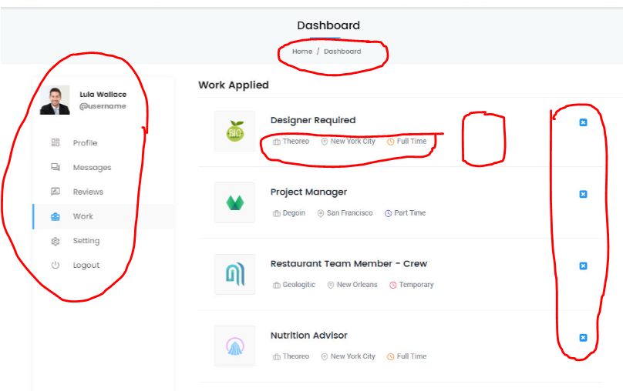

1. Can you change “Home / Dashboard” to “Manage Employment” So that is consistent with what tab they are in.
2. Please can you ensure the left hand menu is the same for all the dashboards, E.g. Change “Works” to “Manage Employment” and Change “Setting” to “Settings”
3. Underneath the job heading, can this show “location” & “potential start date” and “ duration of job “ This can this be pulled through from the job advert.
4. On the right hand side, can there be a “Delete” icon so jobs can be deleted, can there also be a “Chat” and “Email” Icon so the candidate can contact the employer for a potential update.
5. Between the two can there be a “Status” e.g. “Applied” “Shortlisted”

Page 16 – User Message

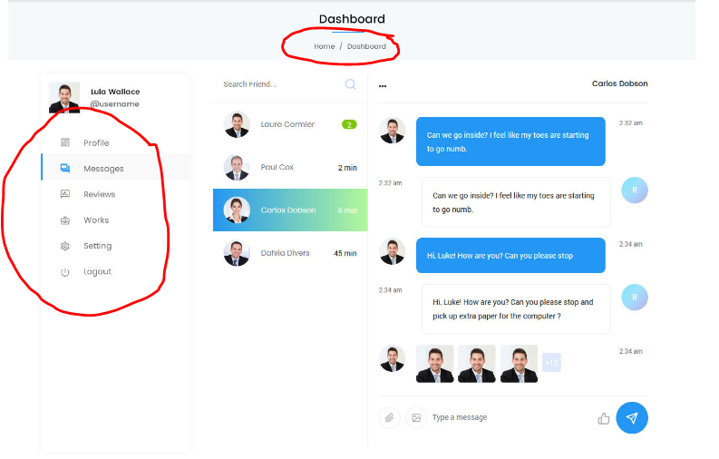

1. Can the “Home / Dashboard” please say “ Home / Messages”
2. Can the left hand menu be consistent with the other pages? E.g. “Works “ be Changed to “Manage Employment”
3. Can the name up the top right hand corner of the page be larger and easier to see who you are chatting with?

Page 17 –User review page changes.

1. Please can you refer back to Employer review page and do the same but on the user point of view.
2. Please change “Home / Dashboard” to “Home / Review”
3. Please can you ensure that the left hand menu is consistent with the other menus? E.g. change “works” to “Manage Employment” and change “Setting” to “Settings”

Page 17 – about us page changes.

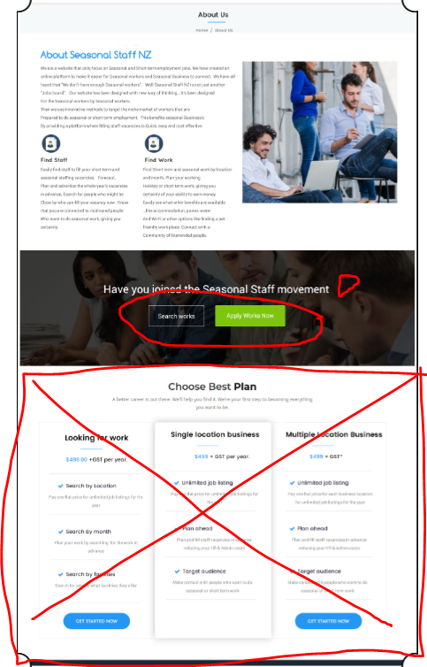

1. Can you put a question mark on the end of “Have you joined the Seasonal Staff Movement Yet?”
2. Can you change the buttons to “Search for Staff” make that a blue button and “Search for jobs” please make that a green button
3. Can you remove the “choose best plan” as we will only have that on the pricing page.
4. Can you put a **large** button down the bottom of the page to “Join Now” this would then take them to the register page?

Page 18 – Blog page changes

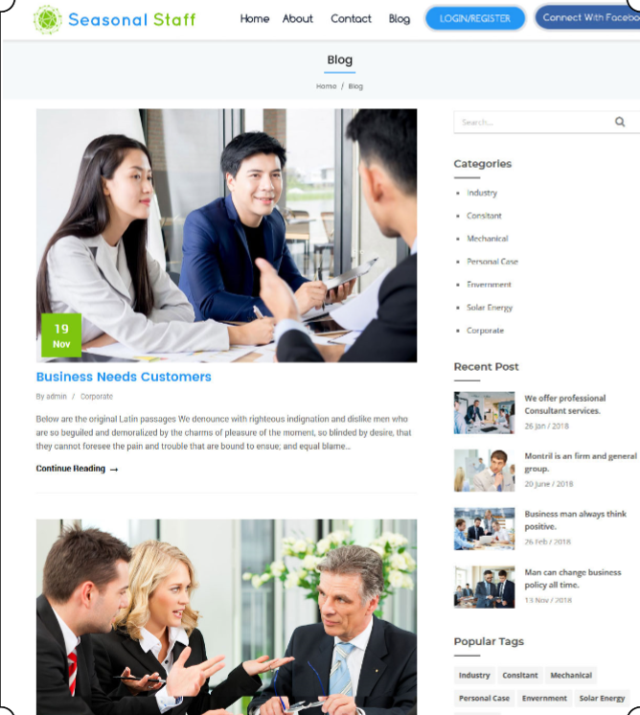

I am happy with the layout of this page, I will look to add contents. Admin need access to this so we can update the content.

Page 19 Contact us page changes.

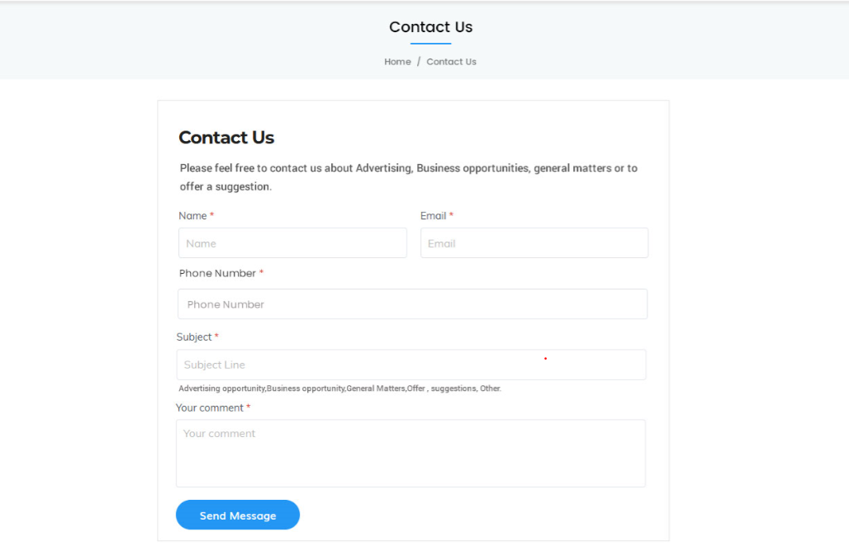

I am happy with this page. No changes needed to be made.

Page 19 – Pricing page changes.

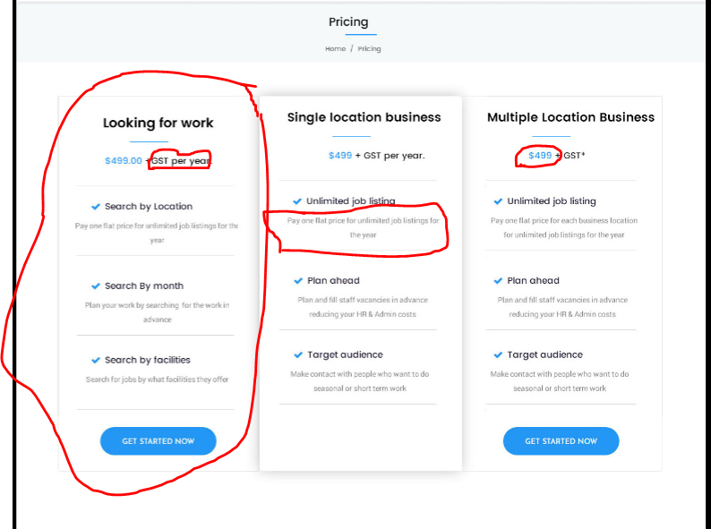

1. Would like the pricing page to only reference “ single business, Multiple location business and Group or Membership”
2. Can “Looking for work” be changed to “Group or Membership” can the price be changed to “please contact us for pricing” Change all the Wording to the same as the “multiple location business” Can this also be put on the other side of the “multiple location Business”
3. On the “single location business” please can you change the wording to” Pay one flat price for unlimited listing for the year for your business”
4. On the “Multiple Location Business” can you please change the price to $199+GST.
5. For the pricing for the “ looking for work” I would like this on a separate page. Only accessable via a link from the “Sign up page”
6. Please can you ensure that this is a link to the pricing for each from the “sign up page”. Eg… link from staff looking for work only can view “ staff looking for work pricing” and “employers” can you see the Employer pricing” Please see below where I would like the pricing link to go. Please can you make it obvious that it they can click on the link/ button to see pricing.

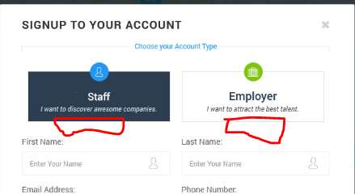

Please can you make also the additional changes

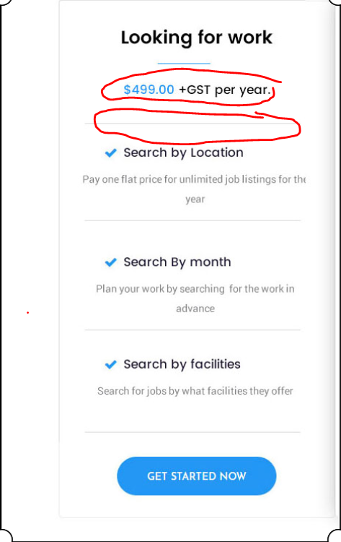

1. Pricing $49 (not GST)
2. Under-pricing can you please add “ Part of a Membership or Group? Please ask if they have arranged a group discount”
3. Then can we have a place where we can list Memberships that have arranged a discount.